Table of Contents

* Introduction
* Problems encountered with your Map
* Overview of the Data
* Other ideas about the datasets
  + Top 5 Contributors’ Geo Tag Maps
    - Mulad
    - iandees
    - stucki1
    - DavidF
    - sota767
* Codes

Introduction

For this project I have chosen my home area Minneapolis, MN. The reason is to be better able to validate the data by cross-referencing the data with personal knowledge of the area. The area is mainly Minneapolis, MN with some of the suburbs including New Brighton, Hopkins, and Minneapolis’ Twin City, St. Paul. Here is a link to the Overpass API for downloading the OSM for the region.  
<http://overpass-api.de/api/map?bbox=-93.3292,44.9150,-93.1713,45.0644>.

All the relevant code will be located in the end of this document with all the links that helped me complete the project.

Below is the Map from OSM.

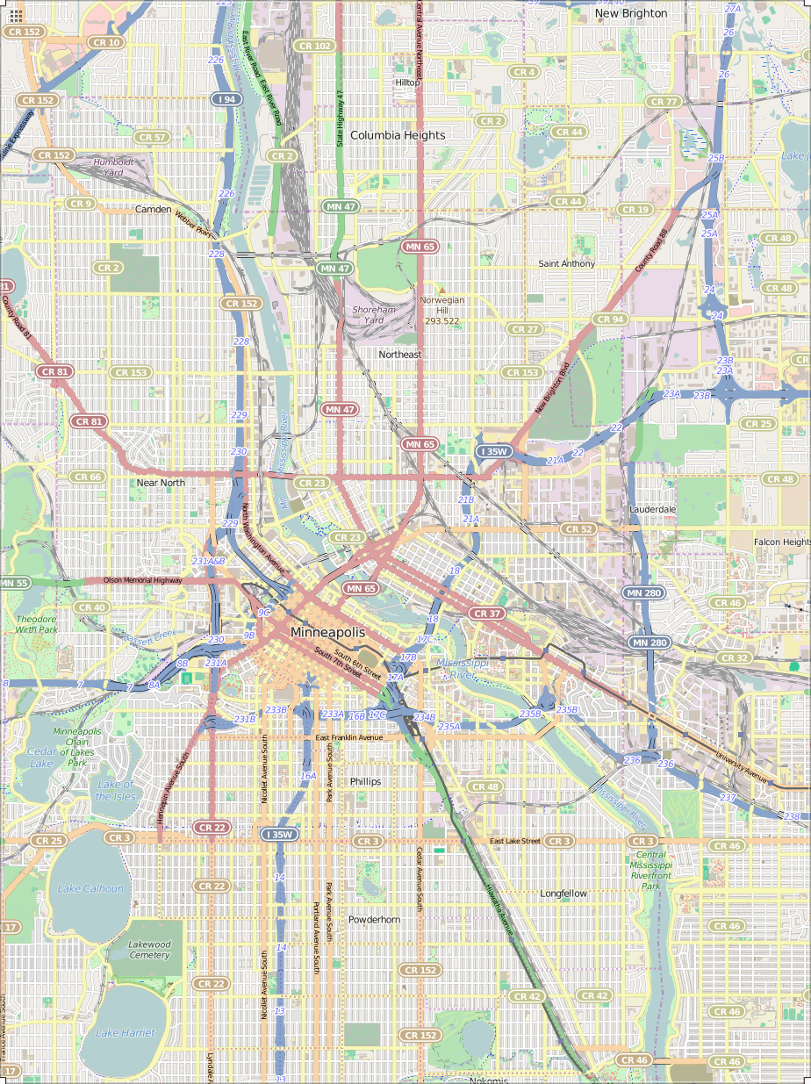

1. Problems encountered in your Map
   * File-size > 87MB
     1. Even with iterative parsing, auditing and identifying meaningful patterns took longer than expected
     2. Took a smaller sample (<12MB) for creating functions for auditing, parsing, cleaning, etc.
     3. Once the functions are complete, they will be applied to the 87MB OSM file
   * Values for cities were redundant
     1. For example—there were 4 different representations of Saint Paul. Here are the mappings

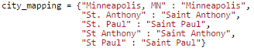

* + Values for postal codes ranged from being 3-digits long to 9-digits, alphabetical, or simply repeated values from different fields (*postcode = street*). One thing to note is out of the 108 unique *postcode* values, once extracting only the 5-digit prefixes, we were left with only 33 unique results which is consistent with the area I’ve chosen.
    1. First I chose to limit the postal codes to 5-digit lengths. This is to standardize the data by the ‘least common denominator’ so the data was more intuitively queryable.
    2. The problem postal codes had letters, were too short, or misplaced from a different field. Some The only way to find the correct postal codes was to search the internet using the other fields for the search criteria and then extrapolate the postal codes. It could be done case-by-case manually but it would be faster if we could do it programmatically.
    3. Luckily I found [pygeocoder](http://code.xster.net/pygeocoder/wiki/Home)
       - Pygeocoder is a Python Library that utilizes Google’s Geocoding Funcitonality to extrapolate geographic information such as coordinates, postal codes, etc.
       - I decided to use the *reverse_geocode()* function which will take the latitudinal and longitudinal coordinates and return an object from which the postal codes could be called from.

> from pygeocoder import Geocoder

> results = Geocoder.reverse_geocode(45.0079126, -93.2473816)

> int(results.postal_code)

> 55418

* + - * There were some *postalcode* fields with did not have coordinate systems to use. Pygeocoder also has the *geocode()* function which takes in a string argument, preferably a street address and state, and returns an object which also contains the postal code information.

> results = Geocoder.geocode('The Carlyle MN')

> int(results.postal_code)

> 55401

* + Values for street suffixes were redundant
    1. The original mapping from Lesson 6 only covered a few keys to be normalized. After sifting through the data, I have discovered many more keys. Here is my mapping for street abbreviations.

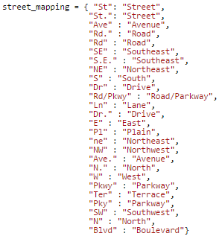

* + The original *shape_element* function created in Lesson 6, when applied to this particular OSM file resulted in 447 unique top-level descriptors. A large number of them had similar prefixes meaning they could be grouped under a single dictionary to simplify querying.

My goal is to aggregate related descriptors into a single top-level key which can be accessed by calling that key. This will result in a more organized representation of the data. The following describes the grouped descriptors and their sources.

* + 1. ‘address:’ fields
       - These were fields dealt with in Lesson 6
    2. ‘metcouncil:’ fields
       - These fields with information from the [Metropolitan Council](http://www.metrocouncil.org/) of Minnesota
    3. ‘tiger:’ fields
       - **T**opologically **I**ntegrated **G**eographic **E**ncoding and **R**eferencing system ([TIGER](http://wiki.openstreetmap.org/wiki/TIGER)) data was produced by the US Census Bureau and later merged onto OSM database
    4. ‘metrogis:’ fields
       - [Regional geographic information](http://wiki.openstreetmap.org/wiki/USGS_GNIS) system of the seven-county metropolitan area of Minneapolis-St. Paul, Minnesota
    5. ‘umn:’ fields
       - Fields related to the University of Minnesota, [example](http://www.openstreetmap.org/way/43328239).
       - This field presented a unique programmatic problem—If it existed, the positional data (Latitude,Longitude) was located in its parent element (in this case *way*), it would be located in a *umn:* k sub-element.
    6. ‘gnis:’ fields
       - USGS **G**eographic **N**ames **I**nformation **S**ystem ([GNIS](http://wiki.openstreetmap.org/wiki/USGS_GNIS)) contains millions of names for geographic features in the US.

After grouping I reduced the number of descriptors from 447 to 364. The fields mentioned above are important because they determine the sources of information merged onto the OSM user-based database. Cross-referencing these fields could determine accuracy, constituency, and completeness of the data.

1. Overview of the Data
   * Statistics
     1. File Sizes
        + map.osm – 87MB
        + map.json – 95MB
     2. Documents

> db.minneapolis.find().count()

> 436802

* + 1. Nodes

> db.minneapolis.find({'type' : 'node'}).count()

> 373017

* + 1. Way

> db.minneapolis.find({'type' : 'way'}).count()

> 59143

* + 1. Unique users

> len(db.minneapolis.distinct('created.user'))

> 401

* + 1. Top 5 contributing users

> pipeline = [{'$group' : {'_id' : '$created.user', 'count' : {'$sum' : 1}}},

{'$sort' : {'count' : -1}},

{'$limit' : 5}]  
> top5 = db.minneapolis.aggregate(pipeline)

> for i in top5['result']:

print i['_id'], i['count']

> Mulad 146082

iandees 81267

stucki1 63803

DavidF 27032

sota767 25901

* + 1. Top 5 contributing areas by city
    2. Asd

1. Other ideas about the Datasets  
    I’ve decided to take the positional data (latitude, longitude) of the top 5 contributing users and create a graphical display of the places they contributed overlaid on the map area the dataset came from. This should create a sort of ‘heat-map’ of each users’ territory, so to speak. We may be able to see home neighborhoods or traveling patterns. The image of the top 5 contributors on to one map became too confusing to interpret so I split it into 5 individual maps/graphs. The codes for making the maps and an explanation of each step of the code will be available in the Codes section.
   * From the previous section we have discovered the top 5 contributors to be…
     1. Mulad – 146082

## Query to find percentage of total documents user contributed

db.minneapolis.find({'created.user': 'Mulad'}).count() / float(db.minneapolis.find().count())

* + - * ~33.4 % of the total documents
    1. iandees – 81267
       - ~18.6 % of the total documents
    2. stucki1 – 63803
       - ~14.6 %
    3. DavidF – 27032
       - ~6.2 %
    4. sota767 – 25901
       - ~5.9
  + There relative map and geotag locations will be shown on the following pages in order of magnitude of contributions.
  + I will also include some notes derived from my personal knowledge of this area that could be of some interest.

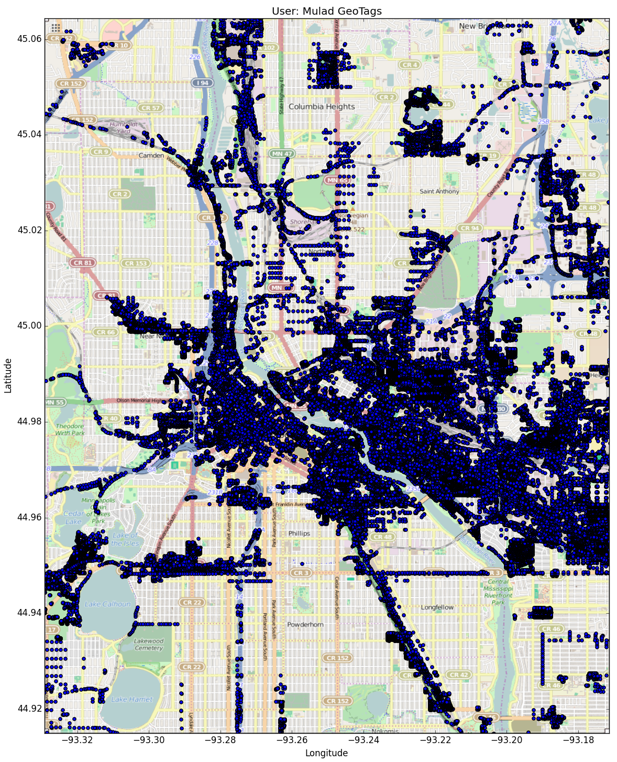

‘Mulad’ geotagged heavily in downtown Minneapolis, east through UofM and St. Paul, and a south stream through Hiawatha/55. These regions are high-frequency public transportation routes especially the Hiawatha Light Rail which is a primary route to connect the southern suburbs into Minneapolis. This could indicate ‘Mulad’ depends on public transportation and/or resides in Minneapolis proper.

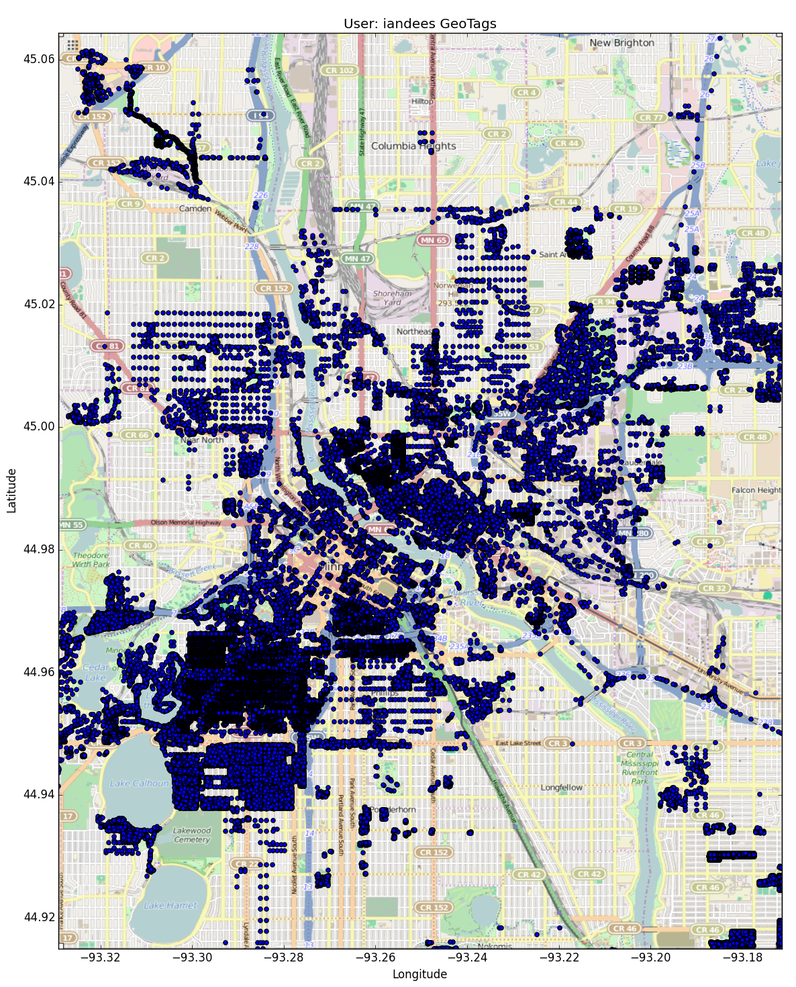

‘iandees’ geotags are primarily in a region of Minneapolis called ‘Uptown’ and runs to Northeast Minneapolis. These two regions, especially ‘Uptown’, are known for a vibrant ‘bar scene’. Such a high concentration in the ‘Uptown’ region could indicate location of home.

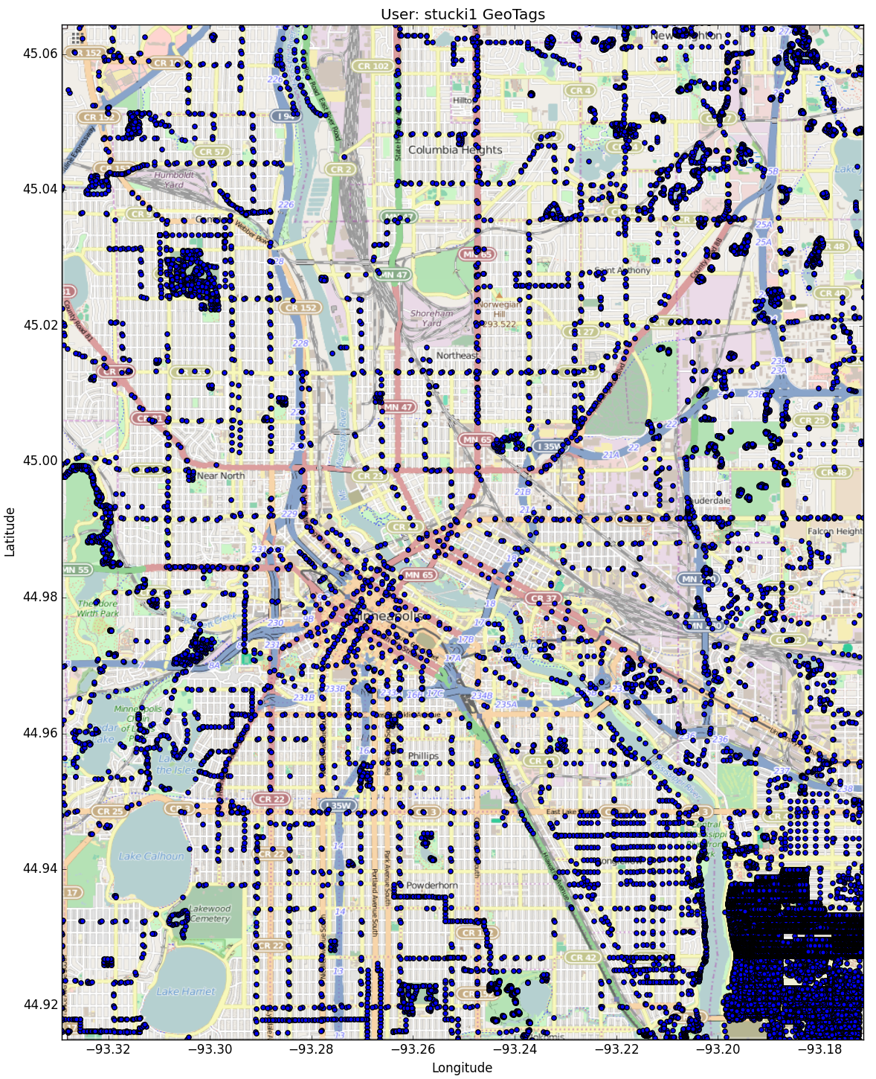

‘stucki1’s geotag patterns show high concentrations in the St. Paul side and a small concentration Northwest in Minneapolis with sparse tags on various intersections throughout the area. The intersection-tags could indicate ‘stucki1’ simply tagging while driving and the high-concentrations could indicate a home area and a work area.

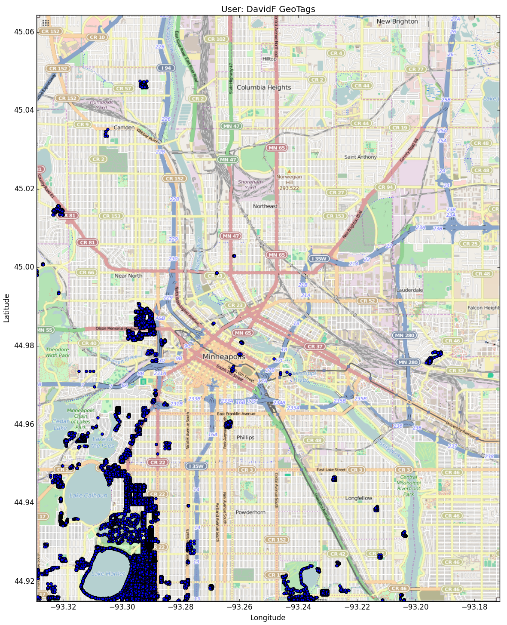

‘DavidF’s geotags are highly concentrated around Lake Harriet/Lake Calhoun area. This area has higher than average housing prices and could indicate personal salary. This could also indicate a frequent area of recreation for the user.

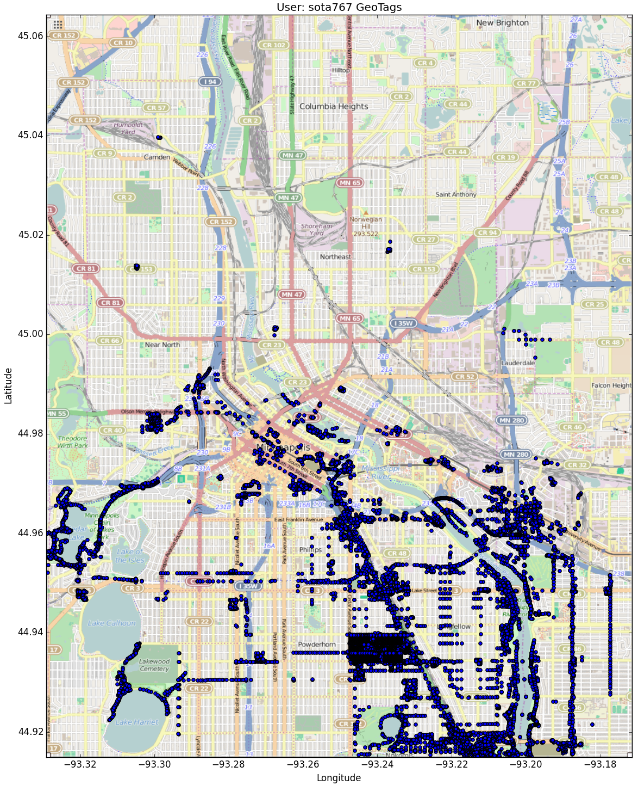

‘sota767’s geotags are indicative of a home region around the Minnehaha falls area. User could also be a student since there are high concentrations in the UofM campus area. His tagging patterns are concentrated in the Hiawatha Light Rail system and along North-South public transportation routes which could indicate a reliance on public transport.

1. Conclusions

* I am inclined to presume that the top 5 geotaggers were hired by OSM or some other geographical tagging association. What leads me to this hypothesis is that these users tagged in specialized areas of the region that, for the most part, did not overlap and, between them, encompass ~79% of the total tags.
* I would also like to recommend a ‘fresh’ start with the geotags. Scanning through the documents I found a lot of key value pairs that did not categorize well and most seemed to be in a random format. These outliers are sparsely dispersed throughout the data and do not occur with a great enough frequency to warrant any sort of pattern. They are simply clutter. These values should be removed and a stricter form of geotagging should be implemented so future tags adhere to a certain standard.
* The positional data, once overlaid on top of the data region yielded some intriguing opportunities. If I were to utilize a larger area, I am sure I would be able to extract some meaningful patterns in users’ geotagging tendencies relative to known geographical features. Many of the top users tagged in highly populated areas of the region leaving some ‘holes’

**Codes**

**xml2dict**() will take an OSM file and return a dictionary it contains the modified shape_element() function which takes each tag that starts with either ‘node’ or ‘way’ and their subelements then cleans the street and city values, then groups according the group elements talked about in section one of this document. After it runs through every line of the OSM file and the final dictionary is created, it runs through the postal codes and replaces the incorrectly formatted codes with the codes derived from the ‘pygeocoder’ module

1. **def** xml2dict(filename):
2. **import** re
3. **import** xml.etree.ElementTree as ET
4. **from** pygeocoder **import** Geocoder
5. expected = ["Street", "Avenue", "Boulevard", "Drive", "Court", "Place", "Square", "Lane", "Road",
6. "Trail", "Parkway", "Commons"]
7. street_type_re = re.compile(r'\b\S+\.?$', re.IGNORECASE)
8. street_mapping = {"St": "Street",
9. "St.": "Street",
10. "Ave" : "Avenue",
11. "Rd." : "Road",
12. "Rd" : "Road",
13. "SE" : "Southeast",
14. "S.E." : "Southeast",
15. "NE" : "Northeast",
16. "S" : "South",
17. "Dr" : "Drive",
18. "Rd/Pkwy" : "Road/Parkway",
19. "Ln" : "Lane",
20. "Dr." : "Drive",
21. "E" : "East",
22. "Pl" : "Plain",
23. "ne" : "Northeast",
24. "NW" : "Northwest",
25. "Ave." : "Avenue",
26. "N." : "North",
27. "W" : "West",
28. "Pkwy" : "Parkway",
29. "Ter" : "Terrace",
30. "Pky" : "Parkway",
31. "SW" : "Southwest",
32. "N" : "North",
33. "Blvd" : "Boulevard"}
34. city_mapping = {"Minneapolis, MN" : "Minneapolis",
35. "St. Anthony" : "Saint Anthony",
36. "St. Paul" : "Saint Paul",
37. "St Anthony" : "Saint Anthony",
38. "St Paul" : "Saint Paul"}
39. CREATED = [ "version", "changeset", "timestamp", "user", "uid"]
40. address = ['addr:unit', 'addr:full','addr:housenumber', 'addr:postcode', 'addr:street',
41. 'addr:city', 'addr:state', 'addr:country',
42. 'addr:suite', 'addr:housename']
43. **def** shape_element(element):
44. node = {}
45. **if** element.tag == "node" **or** element.tag == "way" :
46. node['type'] = element.tag
47. **for** i **in** element.attrib.keys():
48. **if** i **in** CREATED:
49. node['created'] = {}
50. **break**
51. **for** i **in** element.attrib.keys():
52. **if** i **in** CREATED:
53. node['created'][i] = element.attrib[i]
54. **elif** i == 'lon' **or** i == 'lat':
55. **continue**
56. **else**:
57. node[i] = element.attrib[i]
58. **if** 'lat' **in** element.attrib.keys():
59. node['pos'] = [float(element.attrib['lat']), float(element.attrib['lon'])]
60. **for** i **in** element:
61. **if** 'k' **in** i.attrib:
62. **if** i.attrib['k'] **in** address:
63. node['address'] = {}
64. **elif** i.attrib['k'].startswith('metcouncil:'):
65. node['metcouncil'] = {}
66. **elif** i.attrib['k'].startswith('tiger:'):
67. node['tiger'] = {}
68. **elif** i.attrib['k'].startswith('metrogis:'):
69. node['metrogis'] = {}
70. **elif** i.attrib['k'].startswith('umn:'):
71. node['umn'] = {}
72. **elif** i.attrib['k'].startswith('gnis:'):
73. node['gnis'] = {}
74. **for** i **in** element:
75. **if** 'k' **in** i.attrib:
76. **if** i.attrib['k'] **in** ['umn:BuildingCenterXYLatitude', 'umn:BuildingCenterXYLongitude']:
77. node['pos'] = []
78. **break**
79. **for** i **in** element:
80. **if** 'k' **in** i.attrib:
81. **if** i.attrib['k'] == 'umn:BuildingCenterXYLatitude':
82. node['pos'].append(float(i.attrib['v']))
83. **break**
84. **for** i **in** element:
85. **if** 'k' **in** i.attrib:
86. **if** i.attrib['k'] == 'umn:BuildingCenterXYLongitude':
87. node['pos'].append(float(i.attrib['v']))
88. **break**
89. **for** i **in** element:
90. **if** 'ref' **in** i.attrib:
91. node['node_refs'] = []
92. **for** i **in** element:
93. **if** 'k' **in** i.attrib:
94. **if** i.attrib['k'] **in** address:
95. **if** i.attrib['k'] == 'addr:city':
96. **if** i.attrib['v'] **in** city_mapping.keys():
97. node['address'][re.sub('addr:', '', i.attrib['k'])] = city_mapping[i.attrib['v']]
98. **else**:
99. node['address'][re.sub('addr:', '', i.attrib['k'])] = i.attrib['v']
100. **else**:
101. node['address'][re.sub('addr:', '', i.attrib['k'])] = i.attrib['v']
102. **elif** i.attrib['k'].startswith('metcouncil:'):
103. node['metcouncil'][re.sub('metcouncil:', '', i.attrib['k'])] = i.attrib['v']
104. **elif** i.attrib['k'].startswith('tiger:'):
105. node['tiger'][re.sub('tiger:', '', i.attrib['k'])] = i.attrib['v']
106. **elif** i.attrib['k'].startswith('metrogis:'):
107. node['metrogis'][re.sub('metrogis:', '', i.attrib['k'])] = i.attrib['v']
108. **elif** (i.attrib['k'].startswith('umn:') **and**
109. i.attrib['k'] **not** **in** ['umn:BuildingCenterXYLatitude', 'umn:BuildingCenterXYLongitude']):
110. node['umn'][re.sub('umn:', '', i.attrib['k'])] = i.attrib['v']
111. **elif** i.attrib['k'].startswith('gnis:'):
112. node['gnis'][re.sub('gnis:', '', i.attrib['k'])] = i.attrib['v']
113. **elif** ('addr:street:' **in** i.attrib['k'] **or**
114. i.attrib['k'] **in** ['umn:BuildingCenterXYLatitude', 'umn:BuildingCenterXYLongitude']):
115. **continue**
116. **else**:
117. node[i.attrib['k']] = i.attrib['v']
118. **if** 'ref' **in** i.attrib:
119. node['node_refs'].append(i.attrib['ref'])
120. **return** node
121. temp = []
122. data = []
123. **for** _, element **in** ET.iterparse(filename):
124. temp.append(shape_element(element))
125. **for** i **in** temp:
126. **if** i != None:
127. data.append(i)
128. **for** i **in** data:
129. **if** 'address' **in** i:
130. **if** 'street' **in** i['address']:
131. search = street_type_re.search(i['address']['street'])
132. **if** search:
133. **if** street_type_re.search(i['address']['street']).group() **in** street_mapping.keys():
134. data[data.index(i)]['address']['street'] = re.sub(street_type_re.search(i['address']['street']).group(),
135. street_mapping[street_type_re.search(i['address']['street']).group()],
136. data[data.index(i)]['address']['street'])
137. **for** i **in** data:
138. **if** 'address' **in** i **and** 'pos' **in** i:
139. **if** 'postcode' **in** i['address']:
140. **if** len(i['address']['postcode']) < 5 **or** re.search('[a-zA-Z]', i['address']['postcode']):
141. results = Geocoder.reverse_geocode(i['pos'][0], i['pos'][1])
142. i['address']['postcode'] = str(results.postal_code)
143. **elif** 'address' **in** i **and** 'pos' **not** **in** i:
144. **if** 'postcode' **in** i['address']:
145. **if** len(i['address']['postcode']) < 5 **or** re.search('[a-zA-Z]', i['address']['postcode']):
146. q = ''
147. **if** 'housename' **in** i['address']:
148. q = i['address']['housename'] + ' MN'
149. **elif** 'housenumber' **in** i['address'] **and** 'street' **in** i['address']:
150. q = i['address']['housenumber'] + ' ' + i['address']['street'] + ' MN'
151. results = Geocoder.geocode(q)
152. i['address']['postcode'] = str(results.postal_code)
153. **for** i **in** data:
154. **if** 'address' **in** i:
155. **if** 'postcode' **in** i['address']:
156. **if** len(i['address']['postcode']) > 5:
157. i['address']['postcode'] = i['address']['postcode'][0:5]
158. **return** data

**dict2json**() function takes the dictionary created by the xml2dict() function and outputs a json file.

1. **def** dict2json(dict, output_file):
2. **import** codecs
3. **import** json
4. with codecs.open(output_file, 'w') as fo:
5. **for** i **in** dict:
6. fo.write(json.dumps(i) + '\n')
7. fo.close()

**audit_xml**() function is my auditing function. It takes in the osm file for the first argument. The ‘form’ argument specifies what type of audit to return. the default is ‘all’ which returns a dictionary which displays and audit for tags and their attribute/value pairs. ‘tags’ returns simply an audit of the tags. ‘attributes’ returns the first value of the value-pairs. ‘values’ returns an audit of the second value of the value-pairs.

1. **def** audit_xml(filename, form = 'all', value = None):
2. **import** xml.etree.ElementTree as ET
3. **def** count_attrib(filename):
4. attrib_count = {}
5. **for** _, element **in** ET.iterparse(filename):
6. **if** element.tag **in** ['node', 'way', 'tag', 'nd']:
7. **for** i **in** element.attrib.keys():
8. **if** i **not** **in** attrib_count.keys():
9. attrib_count[i] = {'count' : 1}
10. **else**:
11. attrib_count[i]['count'] += 1
12. **return** attrib_count
13. **def** count_val(x, filename):
14. k = {}
15. **for** _, element **in** ET.iterparse(filename):
16. **if** element.tag **in** ['node', 'way', 'tag', 'nd']:
17. **if** x **in** element.attrib:
18. **if** element.attrib[x] **not** **in** k:
19. k[element.attrib[x]] = 1
20. **else**:
21. k[element.attrib[x]] += 1
22. **return** k
23. **def** tag_count(filename):
24. tags = {}
25. **for** _, element **in** ET.iterparse(filename):
26. **if** element.tag **in** ['node', 'way', 'tag', 'nd']:
27. **for** i **in** element:
28. **if** i.tag **not** **in** tags:
29. tags[i.tag] = 1
30. **else**:
31. tags[i.tag] += 1
32. **return** tags
33. **if** form.lower() == 'all':
34. data = {}
35. attrib = count_attrib(filename)
36. **for** i **in** attrib:
37. data[i] = count_val(i, filename)
38. **for** i **in** data:
39. data[i]['TOTAL'] = attrib[i]['count']
40. data['TAGS'] = tag_count(filename)
41. **return** data
42. **elif** form.lower() == 'tags':
43. **return** tag_count(filename)
44. **elif** form.lower() == 'attributes':
45. **return** count_attrib(filename)
46. **elif** form.lower() == 'values':
47. **return** count_val(v, filename)
48. **else**:
49. **if** **not** form **or** form **not** **in** ['all', 'tags', 'attributes', 'values']:
50. **print** "Invalid Audit Type"